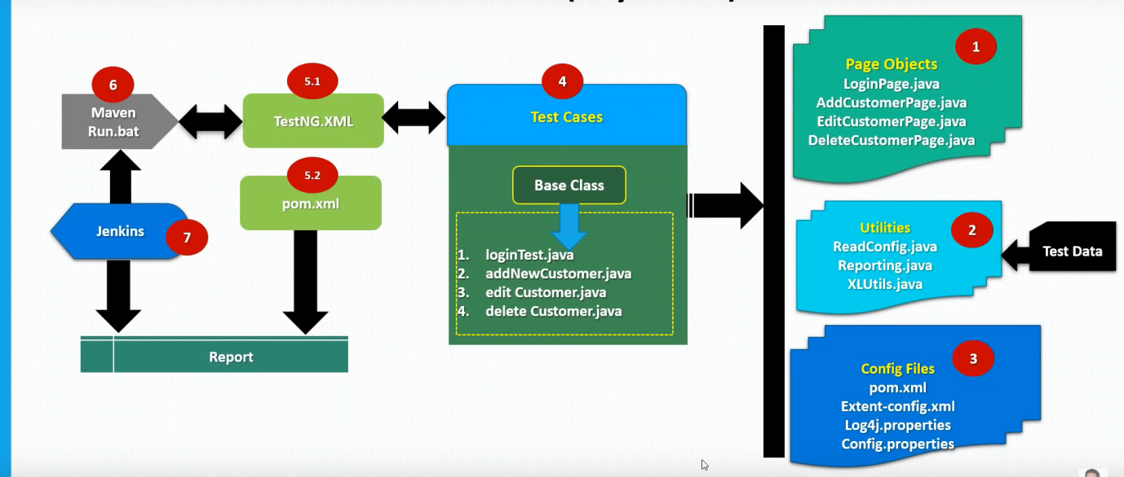

Verify talk talk portal login

Verify NAMS Homepage link

Verify MyNet Homepage link

Verify Service Requests homepage

Verify Raising a Non-Mydesk fault.

Base Class

**Test Cases**

**ConfigurationFiles**

ExtentConfig.xml

Log4j.properties

Configuration.properties

ReadConfig.java

Reporting.java

FetchDatabaseValues.java

XLUtils.java

**Utilities**

TalkTalk Login Page

TalkTalk Home Page

Service Request Page

Raise Request Page

**Page Objects**